The Glen Oaks Little League Challenger Division
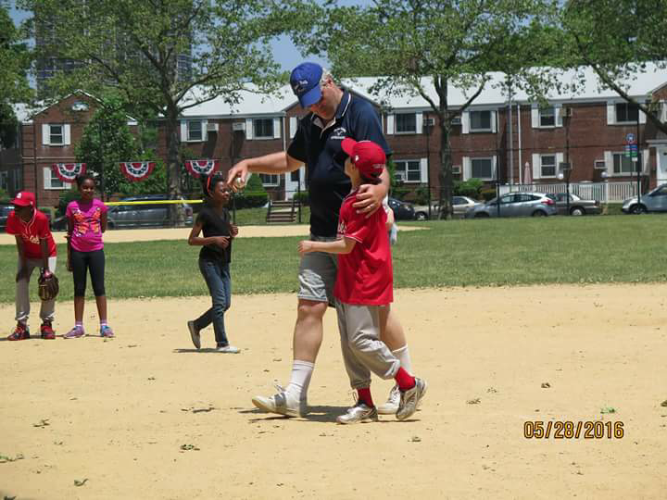
If you have a child that is challenged and you would like them to play baseball. The Glen Oaks Little Challenger Division is just for them. Here we play in a environment that is totally accepting of them.
Here we allow boys and girls with physical and mental Challenges, ages 4 to 18 or up to 21 if they are still in High School, to play ball.
So please foward this email to anyone you think will benifit from this program. Or for more information please contact Dennis Noonan at gobbclinic@aol.com.

